Solution for this Computer Lab contains 3 files and content of all of them is located in Appendix: misprints1.model, misprints2.model, misprints.R.

# Question 1

To show that the results obtained using JAGS model are identical to the ones found theoretically in the class we have plotted (Figure 1) density graph of JAGS model vs Theoretical model.

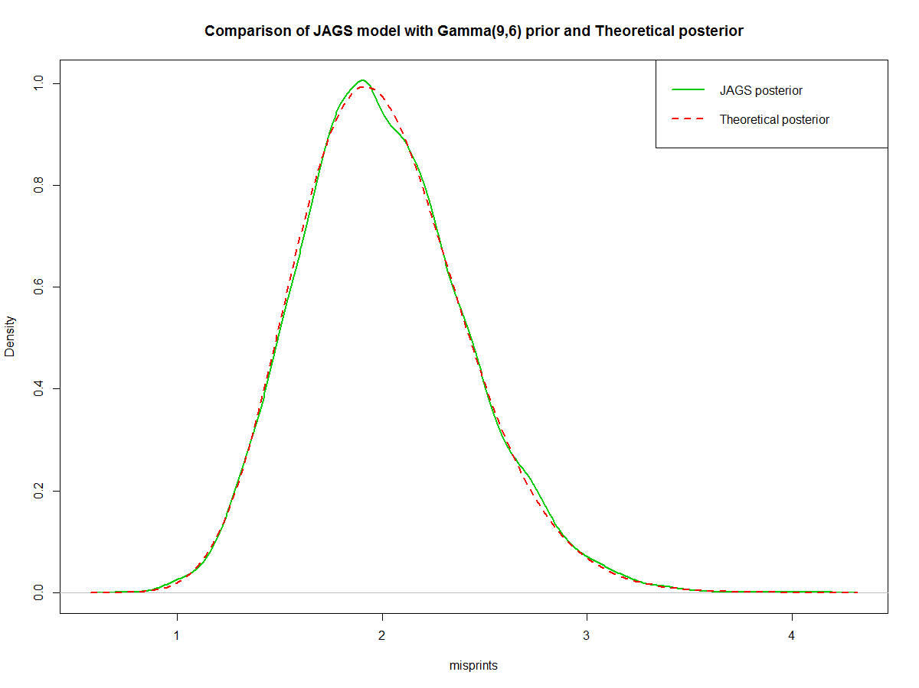

Figure 1. Comparison of JAGS model with Gamma(9,6) prior and Theoretical posterior

As we can see from the Figure 1 the two models align quite well. Additionally, we know that Theoretical posterior should be following $Gamma(24,12)$ distribution therefore its mean is 2 and variance is 0.16667. Our JAGS model has mean of 2.004818 and variance of 0.1672128 which also confirms our findings.

# Question 2

Figure 2 shows comparison between models with different priors: $Gamma(9,6)$, $Uniform\left(0,10\right)$ and Jeffreys’ prior approximated by $Gamma(0.5, 0.00001)$. The most informative distribution is the one with $Gamma(9,6)$ prior. We can also see that the two priors produce similar posterior distributions. The reason they are producing comparable results is that both of them are flat priors as it can be seen on Figure 3.

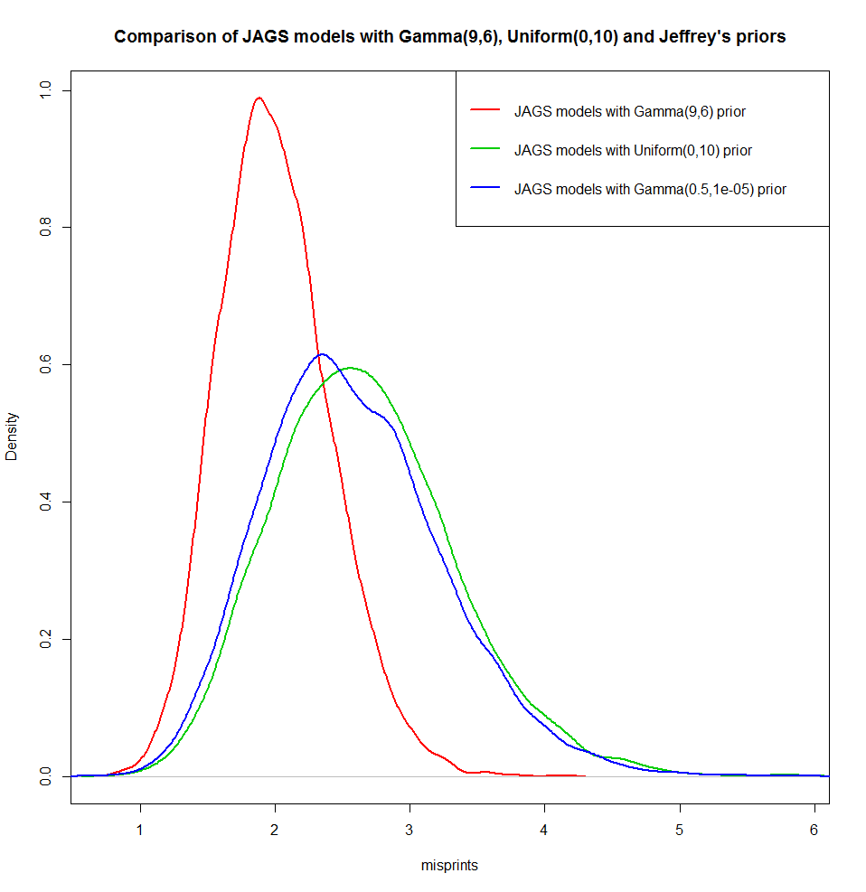

Figure 2. Comparison of JAGS models with 3 different priors

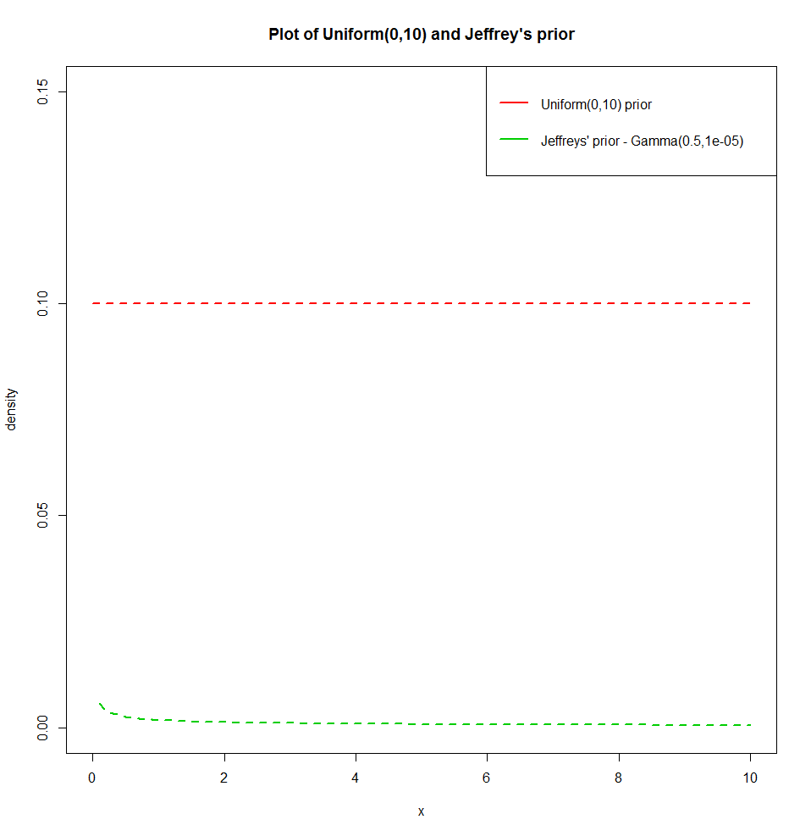

Figure 3. Plot of Uniform(0,10) and Jeffrey's prior

# Question 3

From the Figure 4 we can see that the results are similar for a posterior whose prior distribution is posterior distribution from Question 1 and is calculated using only new data and for a posterior that is calculated using all observed data (old and new) with a prior of $Gamma(9,6)$. The two models produce almost the same results as it can be seen on Figure 4. Additionally, means and variances for the two models are comparable as well as it is expected:

|  |  |  |
| --- | --- | --- |
| Measure | Model 1 (new data) | Model 2 (all observed data) |
| Mean | 2.070024 | 0.1304974 |
| Variance | 2.06378 | 0.1294963 |

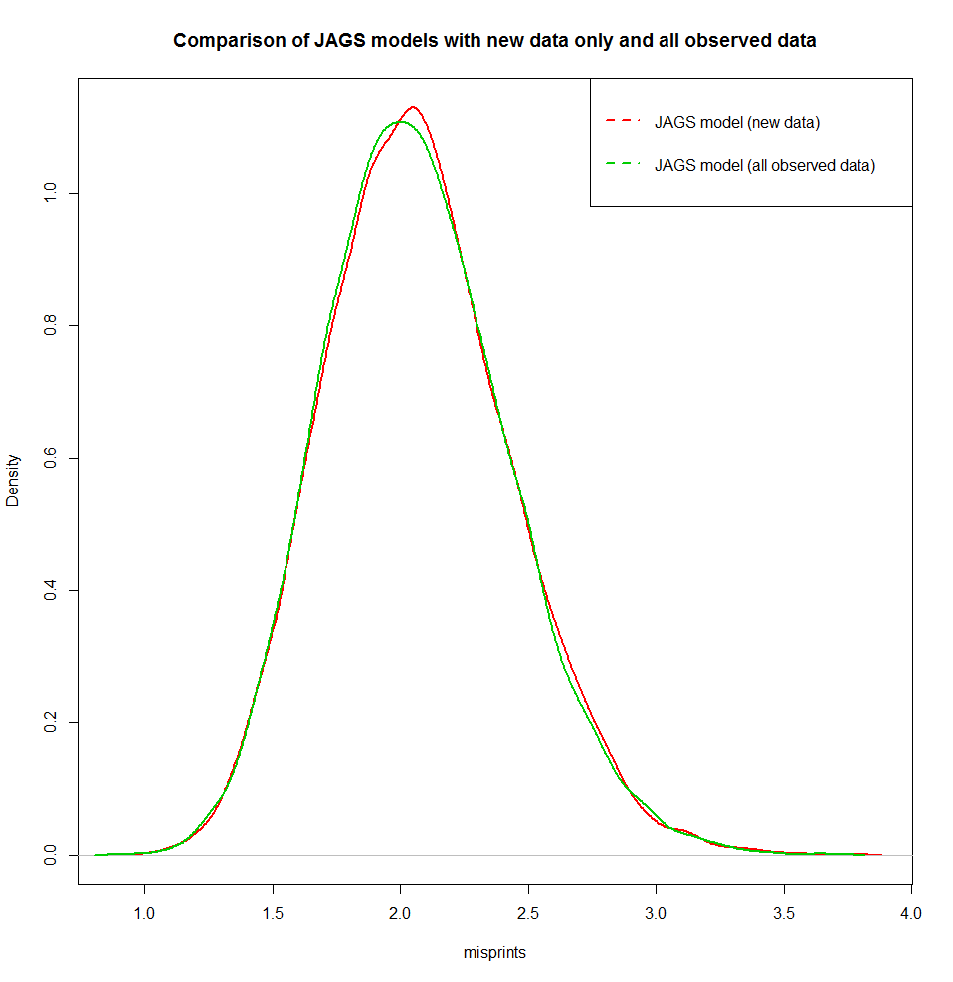

Figure 4. Comparison of JAGS models with new data only vs all observed data

# Appendix

### misprints1.model

model

{

# the likelihood

for(i in 1:N) {

x[i] ~ dpois(lambda)

}

# the prior

lambda ~ dgamma(alpha0, beta0)

}

### misprints2.model

data { # create 3 identical datasets to use with 3 different priors

for (j in 1:3) {

for(i in 1:N) {

x2[i,j] <- x[i]

# x2[1,]=x2[2,]=x and just replicates the data for us

}

}

}

model

{

# Likelihood

for(j in 1:3) { # loop over models

for(i in 1:N) {

x2[i,j] ~ dpois(lambda[j])

}

}

# Priors

lambda[1] ~ dgamma(alpha0, beta0)

lambda[2] ~ dunif(a0, b0)

lambda[3] ~ dgamma(alpha_jeffreys, beta_jeffreys) # need to use small value close to zero as approximateion as using zero fails for calculation

}

### misprints.R

library(rjags)

x_misprints = c(3, 4, 2, 1, 2, 3)

### Question 1 ###

#Data Section

misprints_data1 = list(N=6, x = x_misprints)

# hyperparameters (parameters for the priors)

alpha0 = 9

beta0 = 6

misprints_hypers1 = list(alpha0=alpha0, beta0=beta0)

# save in a single list

misprints1 = append(misprints_data1, misprints_hypers1)

jmodel1 = jags.model(file="misprints1.model", data=misprints1)

samps1 = jags.samples(jmodel1, "lambda", n.iter=10000)

title1 = paste("Comparison of JAGS model with Gamma(", alpha0, ",", beta0,

") prior and Theoretical posterior", sep="")

plot(density(samps1$lambda), col=3, lwd=2, xlab="misprints", main=title1)

# now compare to the theoretical results

alpha0 = 9

beta0 = 6

curve(dgamma(x, 24, 12), add=TRUE, col=2, lwd=2, lty=2) # theoretical posterior

legend("topright", c("JAGS posterior","Theoretical posterior"), lty=c(1,2), col=c(3,2), lwd=c(2,2))

cat("Mean of JAGS posterior: ", mean(samps1$lambda))

cat("Variance of JAGS posterior: ", var(samps1$lambda))

### Question 2 ###

misprints_data2 = list(N=6, x = x_misprints)

# hyperparameters (parameters for the priors)

a0 = 0

b0 = 10

alpha_jeffreys = 0.5

beta_jeffreys = 0.00001

misprints_hypers2 =

list(alpha0=alpha0, beta0=beta0, a0=a0, b0=b0, alpha_jeffreys = alpha_jeffreys, beta_jeffreys = beta_jeffreys)

# save in a single list

misprints2 = append(misprints_data2, misprints_hypers2)

jmodel2 = jags.model(file="misprints2.model", data=misprints2)

samps2 = jags.samples(jmodel2, "lambda", n.iter=10000)

# Comparison

xmin=min(samps2$lambda)

xmax=max(samps2$lambda)

title2 = paste("Comparison of JAGS models with Gamma(", alpha0, ",", beta0,

"), Uniform(", a0, ",", b0,

") and Jeffrey's priors", sep="")

plot(density(samps2$lambda[1,,1]), col=2, lwd=2, xlab="misprints", main=title2, xlim=c(xmin,xmax))

lines(density(samps2$lambda[2,,1]), col=3, lwd=2)

lines(density(samps2$lambda[3,,1]), col=4, lwd=2)

legend("topright",

c(paste("JAGS models with Gamma(", alpha0, ",", beta0, ") prior", sep = ""),

paste("JAGS models with Uniform(", a0, ",", b0,") prior", sep = ""),

paste("JAGS models with Gamma(", alpha_jeffreys, ",", beta_jeffreys, ") prior", sep = "")),

lty=c(1,1,1), col=c(2,3,4), lwd=c(2,2,2))

cat(paste("JAGS model with p(lambda)=Gamma(", alpha0, ",", beta0, ") mean / var = ", sep=""),

mean(samps2$lambda[1,,1]), var(samps2$lambda[1,,1]), "\n")

cat(paste("JAGS model with p(lambda)=Uniform(", a0, ",", b0, ") mean / var = ", sep=""),

mean(samps2$lambda[2,,1]), var(samps2$lambda[2,,1]), "\n")

cat(paste("JAGS model with p(lambda)=Gamma(", alpha_jeffreys, ",", beta_jeffreys, ") mean / var = ", sep=""),

mean(samps2$lambda[3,,1]), var(samps2$lambda[3,,1]), "\n")

plot(1, main=paste("Plot of Uniform(", a0, ",", b0, ") and Jeffrey's prior", sep=""),

xlim = c(0,10), ylim = c(0,0.15), xlab = "x", ylab = "density")

curve(dunif(x, a0, b0), add=TRUE, col=2, lwd=2, lty=2) # Ubiform

curve(dgamma(x, alpha_jeffreys, beta_jeffreys), add=TRUE, col=3, lwd=2, lty=2) # Jeffreys

legend("topright",

c(paste("Uniform(", a0, ",", b0,") prior", sep = ""),

paste("Jeffreys' prior - Gamma(", alpha_jeffreys, ",", beta_jeffreys, ")", sep = "")),

lty=c(1,1), col=c(2,3), lwd=c(2,2))

### Question 3 ###

# New observations with posterior distrbution from Question 1 as a prior

x_newmisprints = c(2,1,6,0)

misprints_data3 = list(N=4, x = x_newmisprints)

# hyperparameters (parameters for the priors)

beta1 = mean(samps1$lambda) / var(samps1$lambda)

alpha1 = mean(samps1$lambda) * beta1

misprints_hypers3 = list(alpha0=alpha1, beta0=beta1)

# save in a single list

misprints3 = append(misprints_data3, misprints_hypers3)

jmodel3 = jags.model(file="misprints1.model", data=misprints3)

samps3 = jags.samples(jmodel3, "lambda", n.iter=10000)

# All observations with original Prior of Gamma(9,6)

misprints_data4 = list(N=10, x = c(x_misprints, x_newmisprints))

# hyperparameters (parameters for the priors)

misprints_hypers4 = list(alpha0=9, beta0=6)

# save in a single list

misprints4 = append(misprints_data4, misprints_hypers4)

jmodel4 = jags.model(file="misprints1.model", data=misprints4)

samps4 = jags.samples(jmodel4, "lambda", n.iter=10000)

# Comparison

title3 = "Comparison of JAGS models with new data only and all observed data"

plot(density(samps3$lambda), col=2, lwd=2, xlab="misprints", main=title3)

lines(density(samps4$lambda), col=3, lwd=2)

legend("topright", c("JAGS model (new data)", "JAGS model (all observed data)"), lty=c(2,2), col=c(2,3), lwd=c(2,2))

cat(paste("JAGS model (new data) with p(lambda)=Gamma(", alpha1, ",", beta1, ") mean / var = ", sep=""),

mean(samps3$lambda), var(samps3$lambda), "\n")

cat(paste("JAGS model (all observed data) p(lambda)=Gamma(", alpha0, ",", beta0, ") mean / var = ", sep=""),

mean(samps4$lambda), var(samps4$lambda), "\n")